1.Draw a **class diagram** using StarUML **models University Courses**.

Prac1

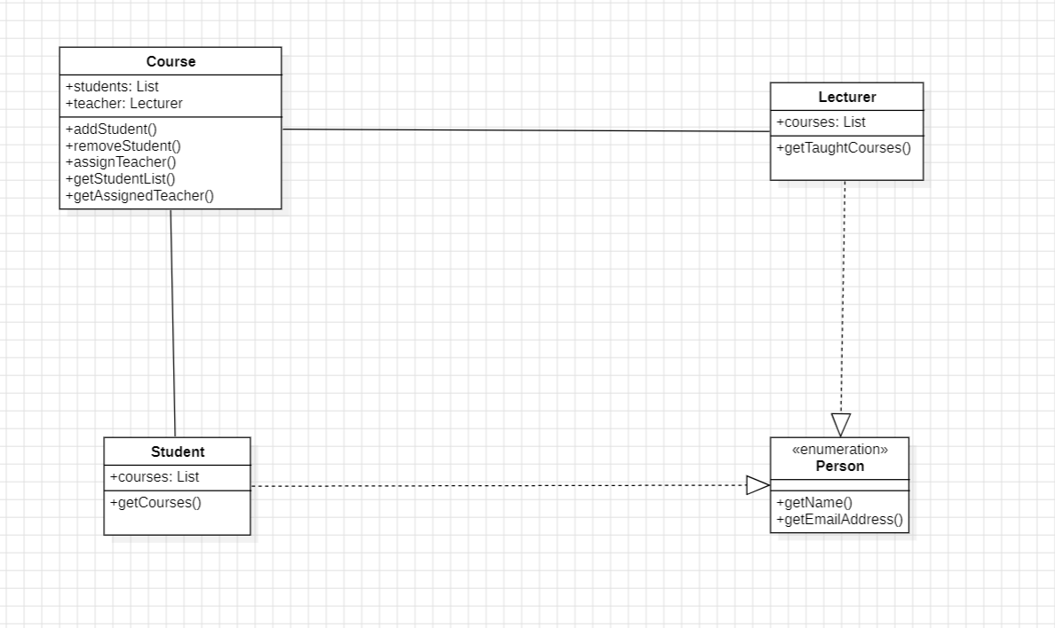

**2.Construct a clean and concise ER diagram for the NHL database**

Prac2

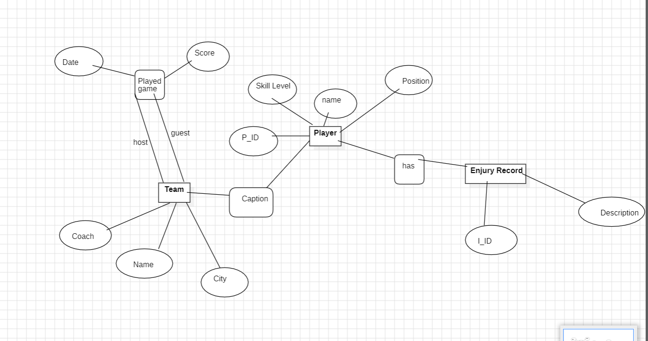

3.Draw a **Deployment diagram** using StarUML for **ATM system –withdraw**

**transaction.**

Prac3

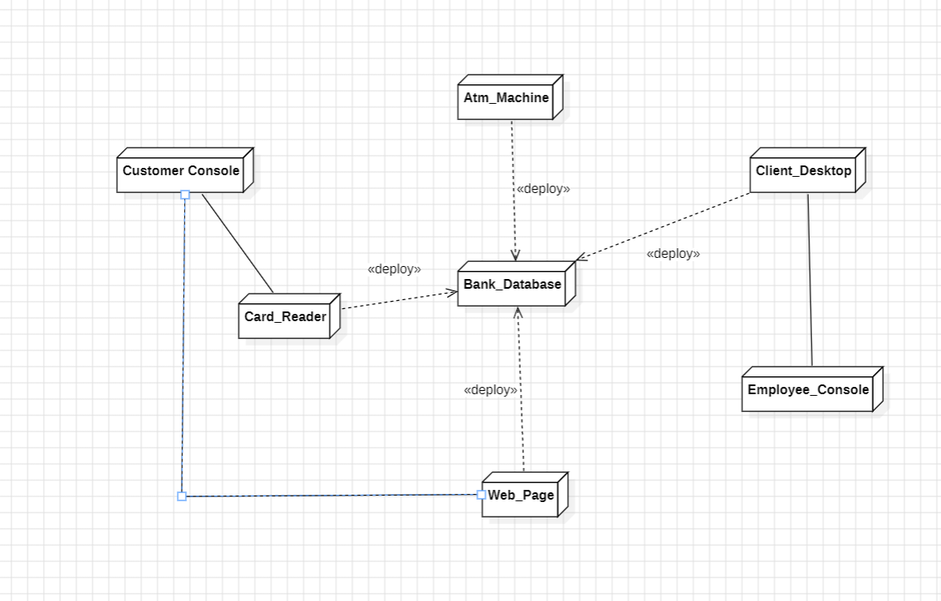

4.Draw a **component diagram** for the **Hospital Management System** . It also keeps the track of customers.

Prac4

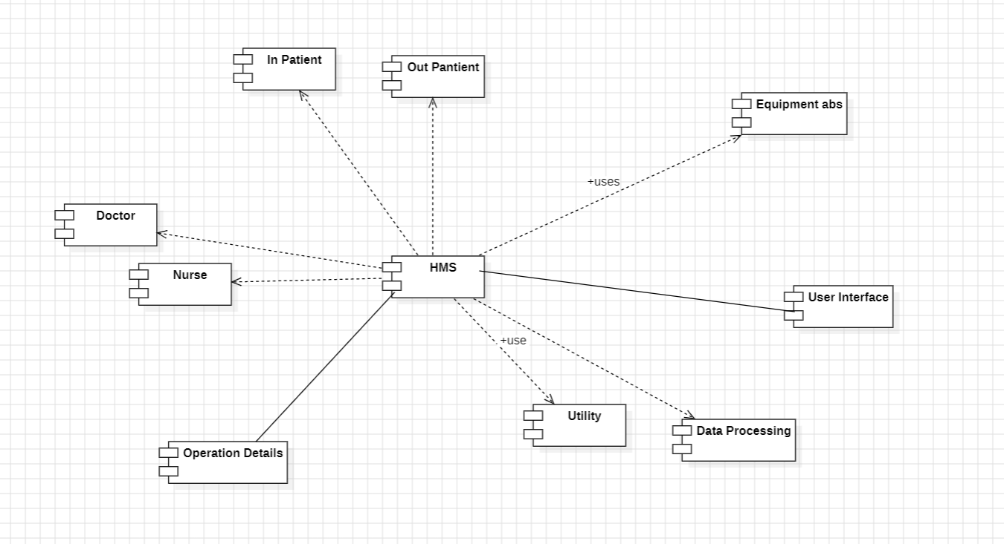

5.Draw a **class diagram** models companies for a payroll or reporting system.

Prac5

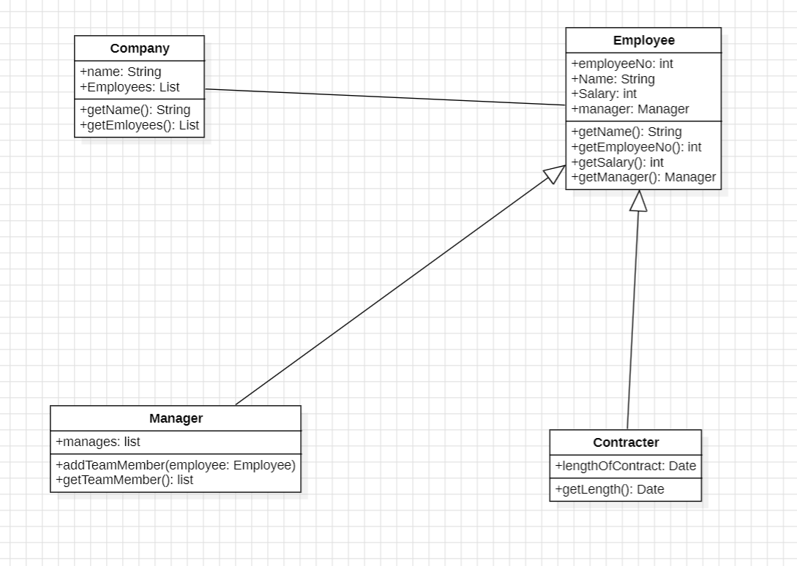

**Use case Diagram** to represent this air transportation system

Prac6

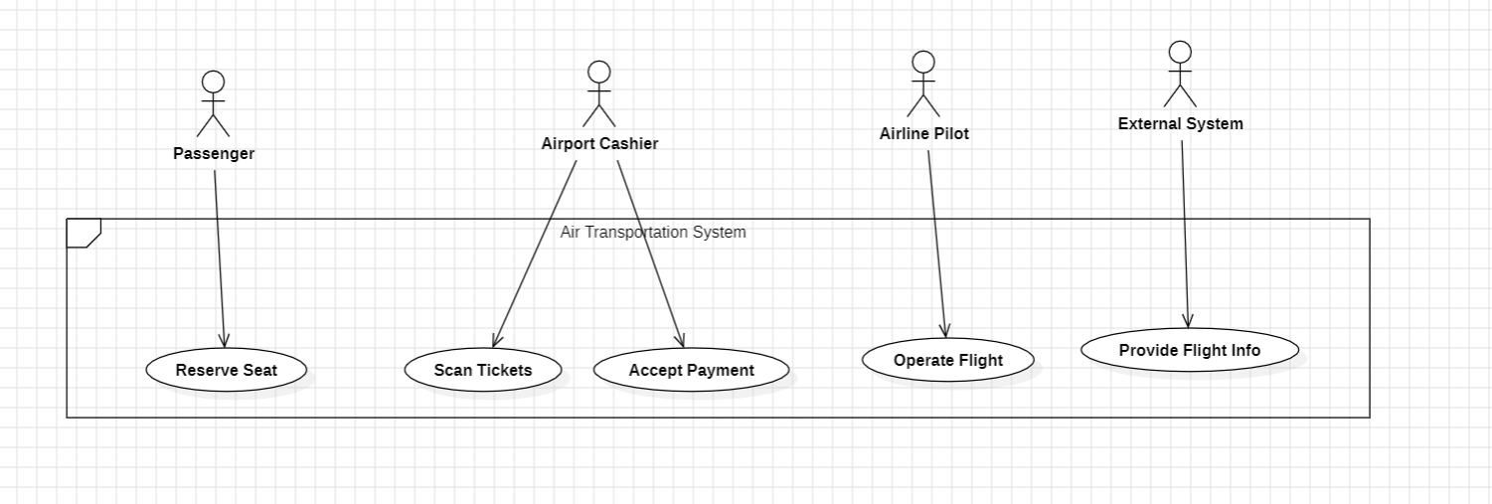

**7.Draw a state transition diagram for a Librarian**

Prac7

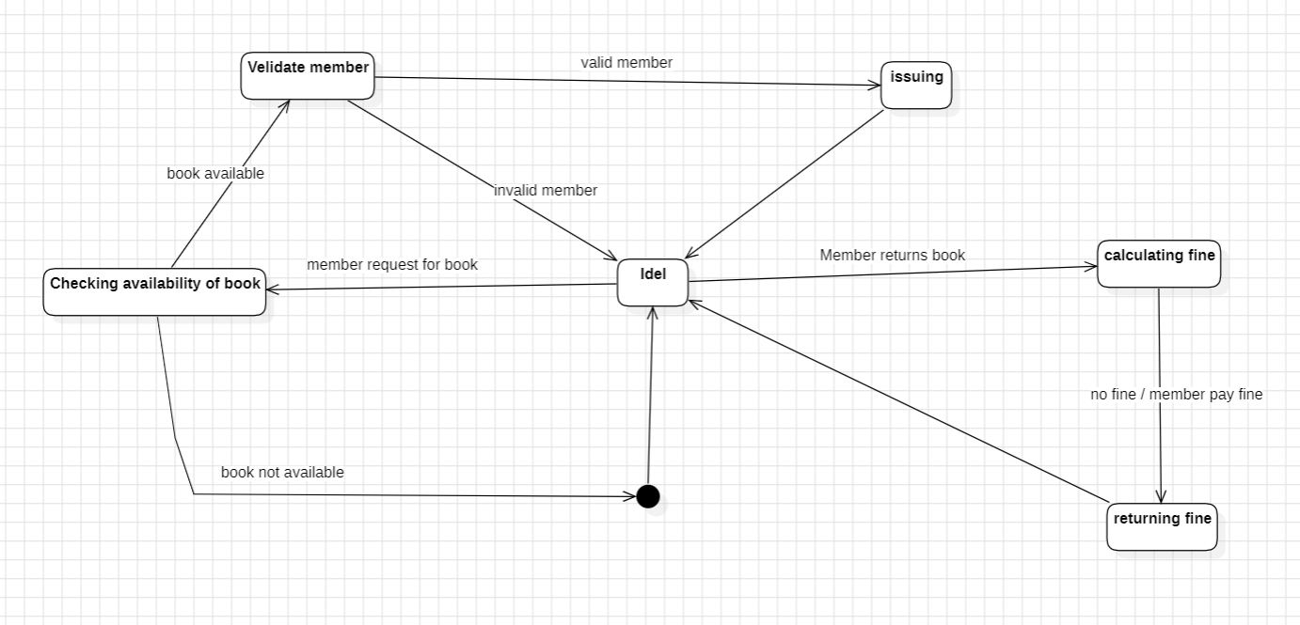

8.Draw a **collaboration diagram** using StarUML for ATM system withdraw money

transaction.

Prac8

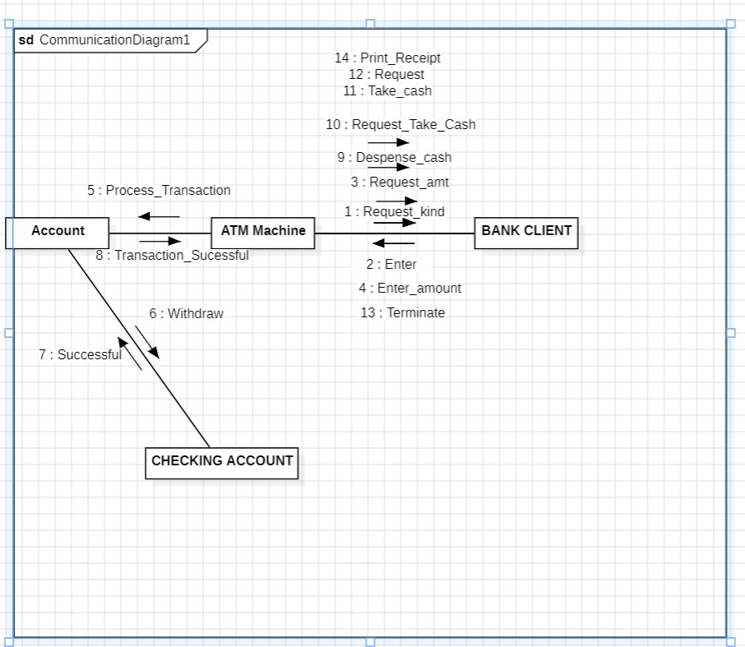

**9.Draw an Activity Diagram for ATM Machine**

Prac9

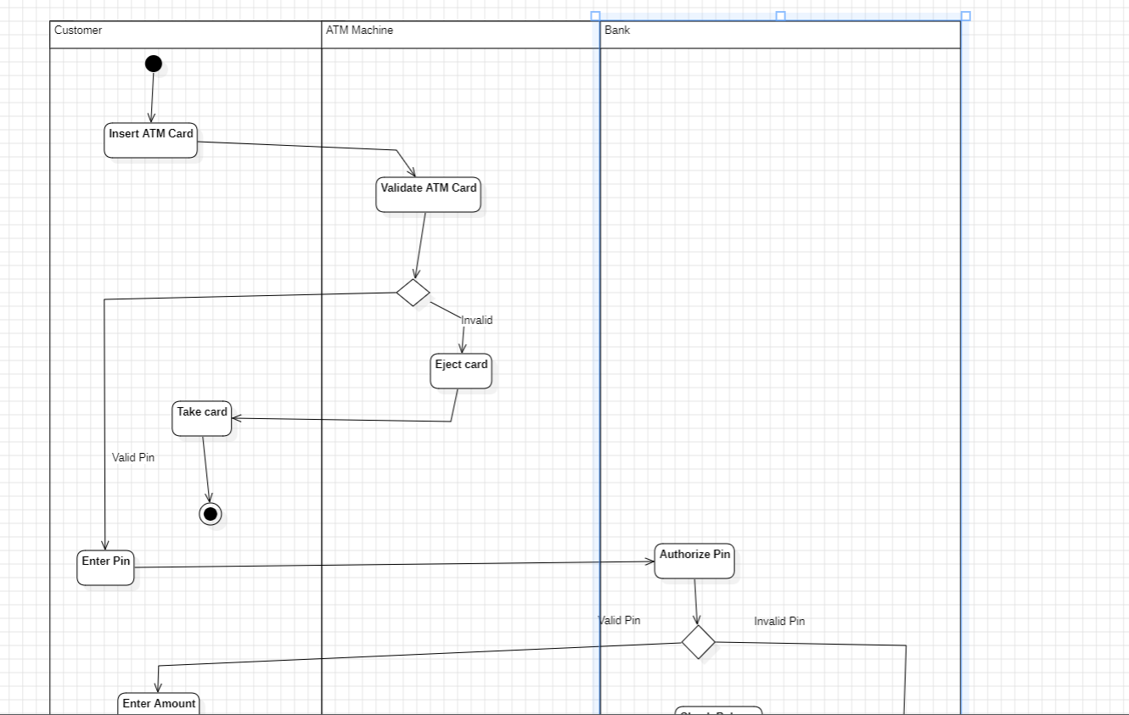

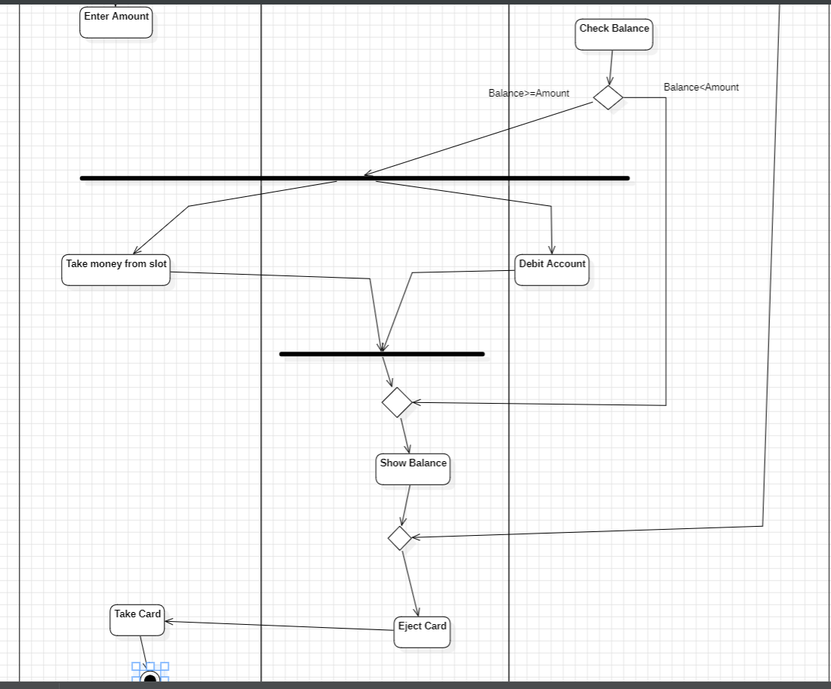

**10.Class Diagram** to represent this air transportation system.

Prac10

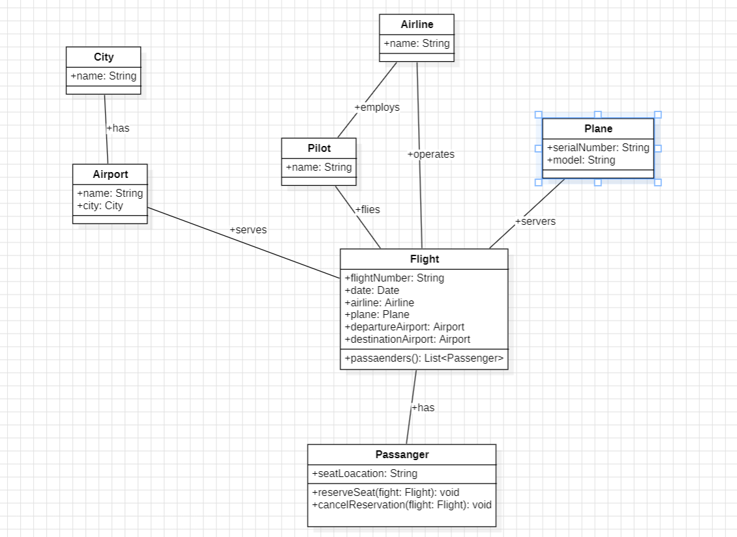

**11.Draw a Activity diagram for online Food Ordering System**

Prac11

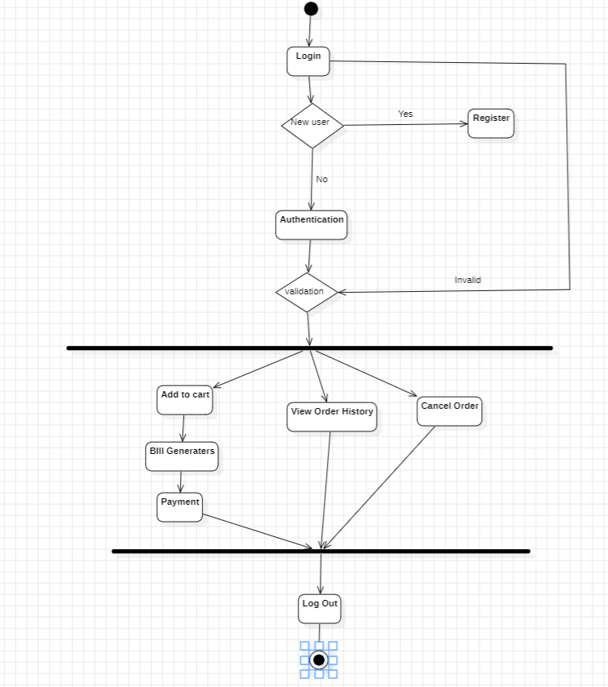

**12.Draw a class Diagram of online Library Management System**

Prac12

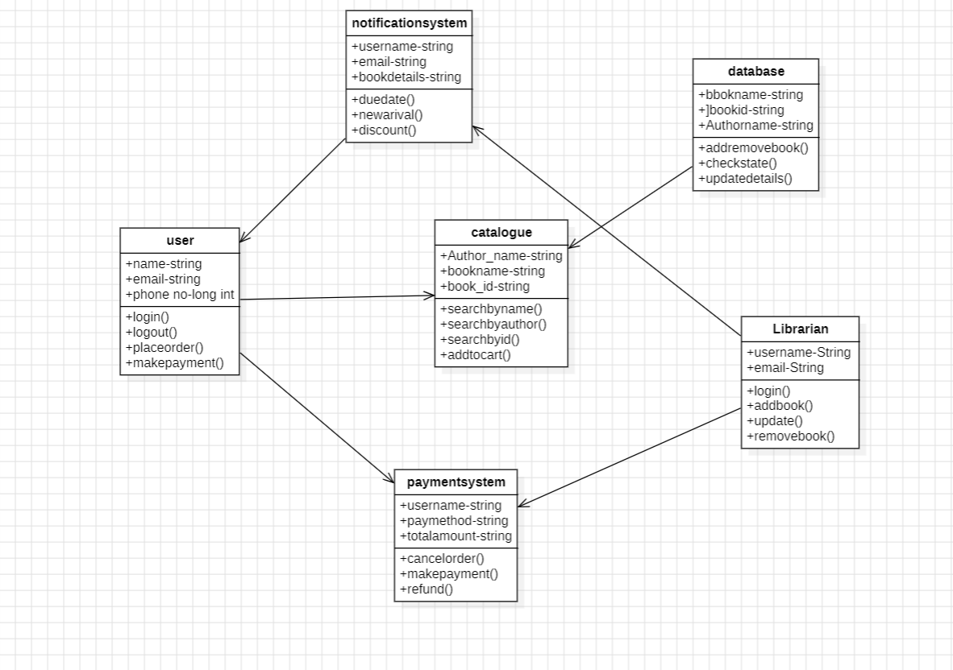

**13.Construct an E-R diagram for the registrar’s office. Document all assumptions that you make about the mapping constraints.**

Prac13(in prac10 )

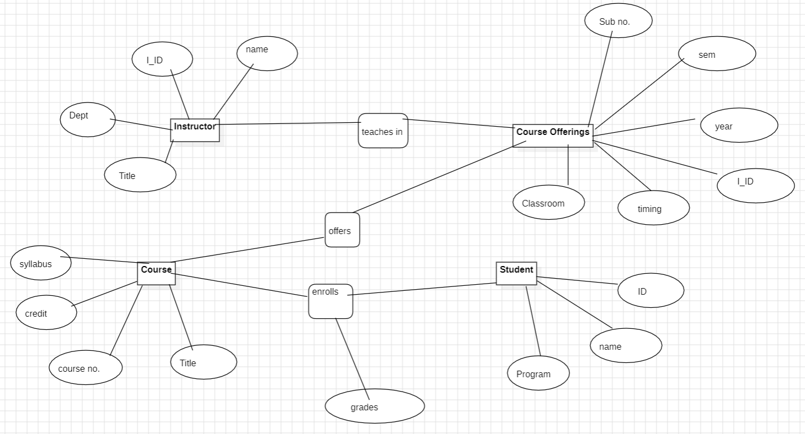

Prac14(same) **Draw a state transition diagram for a Librarian.**

Prac15 Draw a **Class diagram** for ATM Syatem

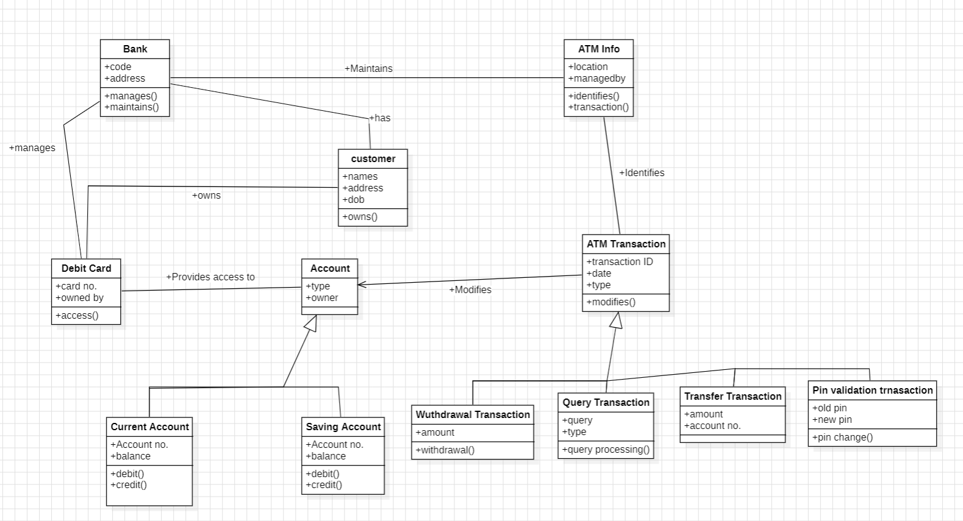

Prac16 **Use case Diagram** to represent this air transportation system.

(same)